Finding resistance of unknown resistor by color coding method

LAB # 2



Spring 2022

CIRCUIT AND SYSTEMS 1 LAB

Submitted by: MUHAMMAD SADEEQ

Registration No.: 21PWCSE2028

Section: C

"On my honor, as student of University of Engineering and Technology, I have neither given nor received unauthorized assistance on this academic work.'

Submitted to:

Engr. Faiz Ullah

(April 14, 2022)

Department of Computer Systems Engineering University of Engineering and Technology, Peshawar

**ASSESSMENT RUBRICS LAB # 02**

**To find the Resistance of a Resistor by Color Code Method**

|  |  |  |  |  |  |
| --- | --- | --- | --- | --- | --- |
|  | **LAB REPORT ASSESSMENT** | | | | |
|  | **Criteria** | **Excellent** | **Average** | **Nil** | **Marks**  **Obtained** |
| **1.** | **Objectives of**  **Lab** | All objectives of lab are properly covered  [Marks 1] | Objectives of lab are partially covered  [Marks 0.5] | Objectives of lab are not shown [Marks 0] |  |
| **2.** | **Resistance and its Units** | Resistance and its units are well defined  [Marks 1] | Resistance and its units, if one of them is missing or partially defined [Marks 0.5] | Resistance and its units are missing.  [Marks 0] |  |
| **3.** | **Color Coding Method.** | Define Color Coding Method properly and properly labeled diagram.  [Marks 2] | Color Coding Method is not properly defined and diagram is shown with no labels.  [Marks 1] | Color coding method is not defined and diagram is not shown  [Marks 0] |  |
| **4.** | **Color Coding Table** | Color coding table is shown with all range of resistances along with their corresponding bands. [Marks 3] | Color coding table is partially shown with resistances and corresponding bands.  [Marks 1.5] | No color coding table is shown [Marks 0] |  |
| **5.** | **Experimental Results** | All experimental results are completely shown in form of table for varying resistors and verification through DMM is also shown. [Marks 3] | Experimental results are partially shown and some of the observations are missing [Marks 1.5] | No experimental results are shown  [Marks 0] |  |
|  | Total Marks Obtained: __________  Instructor Signature: ______________________ | | | | |

**Experiment # 2**

Finding resistance of unknown resistor by color coding method

**Objective:**

To find the resistance of unknown resistor using color coding method.

**Resistance and its Units:**

Resistance is a measure of the opposition to current flow in an electrical circuit. Resistance is measured in ohms, symbolized by the Greek letter omega (Ω).

**Mathematically:**

R=V/I

**Unit:**

The unit of resistance is ohm. One ohm is defined as when one volt of potential difference produces one Ampere of current through the conductor.

**Color coding method:**

The Resistor Color Code system is all well and good but we need to understand how to apply it in order to get the correct value of the resistor. The “left-hand” or the most significant colored band is the band which is nearest to a connecting lead with the color coded bands being read from left-to-right as follows:

Digit, Digit, Multiplier = Color, Color x 10color in Ohm’s (Ω)

For example, a resistor has the following colored markings;

Yellow Violet Red = 4 7 2 = 4 7 x 102 = 4700Ω or 4k7 Ohm.

The fourth and fifth bands are used to determine the percentage tolerance of the resistor. Resistor tolerance is a measure of the resistors variation from the specified resistive value and is a consequence of the manufacturing process and is expressed as a percentage of its “nominal” or preferred value.

Typical resistor tolerances for film resistors range from 1% to 10% while carbon resistors have tolerances up to 20%. Resistors with tolerances lower than 2% are called precision resistors with the or lower tolerance resistors being more expensive.

Most five band resistors are precision resistors with tolerances of either 1% or 2% while most of the four band resistors have tolerances of 5%, 10% and 20%. The color code used to denote the tolerance rating of a resistor is given as:

Brown = 1%, Red = 2%, Gold = 5%, Silver = 10 %

If resistor has no fourth tolerance band then the default tolerance would be at 20%.

It is sometimes easier to remember the resistor color code by using short, easily remembered sentences in the form of expressions, rhymes, and phrases, called an *acrostic*, which have a separate word in the sentence to represent each of the Ten + Two colors.

The resulting mnemonic matches the first letter of each word to each color which makes up the resistors color code by order of increasing magnitude and there are many different mnemonic phrases which can be used. However, these sayings are often very crude but never the less effective for remembering the resistor colors. Here are just one of the more “cleaner” version but many more exists:

* **B**ad **B**oys **R**ing **O**ur **Y**oung **G**irls **B**ut **V**icky **G**oes **W**ithout

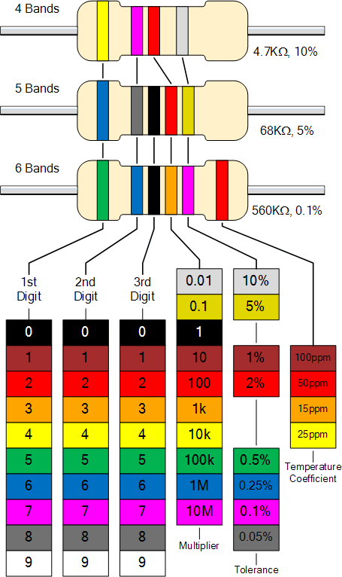

**Color Coding Table:**

|  |  |  |  |  |  |  |
| --- | --- | --- | --- | --- | --- | --- |
| **Color** |  | **1st Band** |  | **2nd Band** | **3rd Band** | **4th Band**  **( Tolerance )** |
| Black | 0 |  | 0 |  | 100 |  |
| Brown | 1 |  | 1 |  | 101 | ±1 % |
| Red | 2 |  | 2 |  | 102 | ±2 % |
| Orange | 3 |  | 3 |  | 103 |  |
| Yellow | 4 |  | 4 |  | 104 |  |
| Green | 5 |  | 5 |  | 105 | ± 0.5 % |
| Blue | 6 |  | 6 |  | 106 | ±0.25 % |
| Violet | 7 |  | 7 |  | 107 | ±0.1 % |
| Gray | 8 |  | 8 |  | 108 | ±0.05 % |
| White | 9 |  | 9 |  | 109 |  |
| Gold |  |  |  |  |  | ± 5 % |
| Silver |  |  |  |  |  | ± 10 % |
| No Color |  |  |  |  |  | ± 20 % |

**Experimental Results:**

|  |  |  |  |  |  |  |  |
| --- | --- | --- | --- | --- | --- | --- | --- |
| **S.no.** | **1st Band** | **2nd Band** | **3rd Band** | **4th Band**  **Tolerance** | **Resistance**  **(Color Code) (Ω)** | **Range of resistance**  **(Ω)** | **Verification by DMM**  **(Ω)** |
| 1. | Orange(3) | Orange(3) | Orange(103) | ± 5 % | 33k | 31350-34650 | 33.6k |
| 2. | Brown(1) | Black(0) | Orange(103) | ± 5 % | 10k | 9500-10500 | 9.8k |
| 3. | Brown(1) | Black(0) | Green(105) | ± 5 % | 1M | 950k-1050k | 980k |
| 4. | Red(2) | Red(2) | Orange(103) | ± 5 % | 22k | 20900-23100 | 21.4k |
| 5. | Red(2) | Red(2) | Red(102) | ± 5 % | 2.2k | 2090-2310 | 2.14k |